# RSI-Based Trading Signal Construction (Corrected)

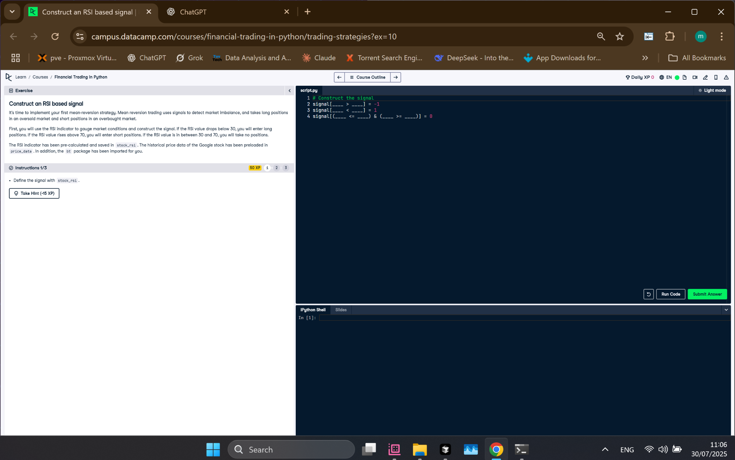

Figure: RSI Signal Construction Exercise Screenshot

## Python Code

# Construct the signal  
signal[stock_rsi > 70] = -1  
signal[stock_rsi < 30] = 1  
signal[(stock_rsi <= 70) & (stock_rsi >= 30)] = 0

## Explanation

This code builds a trading signal using the RSI indicator. When RSI is over 70 (overbought), it gives a sell signal (-1). If RSI is under 30 (oversold), it gives a buy signal (1). If RSI is between 30 and 70, no action is taken (0).